**Hormonal Control of Reproduction – Notes**

* The menstrual and ovarian cycles depend on the **endocrine glands** for their **regulation and control**.
* Endocrine glands **secrete hormones** into extracellular fluid surrounding the cells that make up the gland.
* The secretion then usually **passes through the capillaries** to be **transported via blood**.

**Reproductive hormones**:

|  |  |  |
| --- | --- | --- |
| **Hormone**: | **Target organ**: | **Effect of hormone**: |
| Follicle-stimulating hormone (FSH) from | Seminiferous tubules of testes. | Production of sperm. |
| pituitary gland | Follicles of ovaries. | Maturation of ovarian follicles. |
| Human chorionic gonadotropin. | Corpus luteum. | Maintenance of corpus luteum during early stages of pregnancy. |
| Lactogenic hormone (prolactin) from pituitary gland. | Breasts. | Production of milk in activated glands. |
| Luteinising hormone from pituitary gland. | Interstitial cells of testes. | Stimulates secretion of testosterone. |
|  | Cells of the ovaries. | Stimulates secretions of oestrogen and progesterone. |
| Oestrogens from ovarian follicle and corpus luteum. | Various. | Development of female reproductive system. |
|  |  | Development of secondary sexual characteristics. |
| Oxytocin from pituitary gland. | Uterus. | Stimulates contraction of smooth muscle. |
|  | Breasts. | Promotes contraction of muscle cells surrounding breast lobules. |
| Progesterone from corpus luteum. | Uterus. | Maintenance of endometrium. |
|  | Placenta. | Development and maintenance of placenta. |
|  | Breasts. | Development of milk-secreting glands. |
| Testosterone from cells in testis. | Various. | Development of male reproductive system. |
|  |  | Development of secondary sexual characteristics. |

Gonadotropins:

1. Follicle-stimulating hormone (FSH) – Stimulates the **development and maturation of the ovarian follicle** in the female.

* During its own development, the **ovarian follicle secretes oestrogen**.
* **Secretion of FSH is reduced** as the level of oestrogen increases in the blood.

2. Luteinising hormone (LH) – Promotes final **maturation of the ovarian follicle** (ovulation) and the **formation of the corpus luteum**.

* Corpus luteum secretes **progesterone** as well as **oestrogens**.
* There’s a gradual **reduction in the production of LH** as the level of **progesterone in the blood increases**.
* The **corpus luteum is** **maintained by human chorionic gonadotropin (HCG)**, a hormone produced by the developing placenta in a pregnant woman.
* Once the placenta is itself able to secrete oestrogens and progesterone, the **corpus luteum begins to degenerate**.
* Pituitary gland secretes lactogenic hormone (**prolactin (not gonadotropic)**). This hormone has a direct effect on the breasts of the woman and is important in the **preparation and maintenance of milk production**.

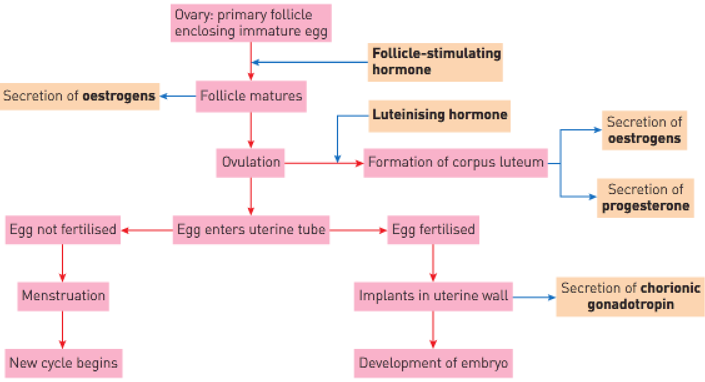

In males:

* **FSH stimulates the epithelial tissue of the seminiferous tubules in the testes** to **produce sperm**.
* **LH stimulates cells in the testes** to secrete **testosterone** which is important for the **development of immature sperm cells** into mature spermatozoa and has a major role in the **maintenance of the male reproductive organs and sex drive**.
* The production of testosterone influences the development of the body to sexual maturity. In females, the same sexual maturation is brought about by oestrogens.

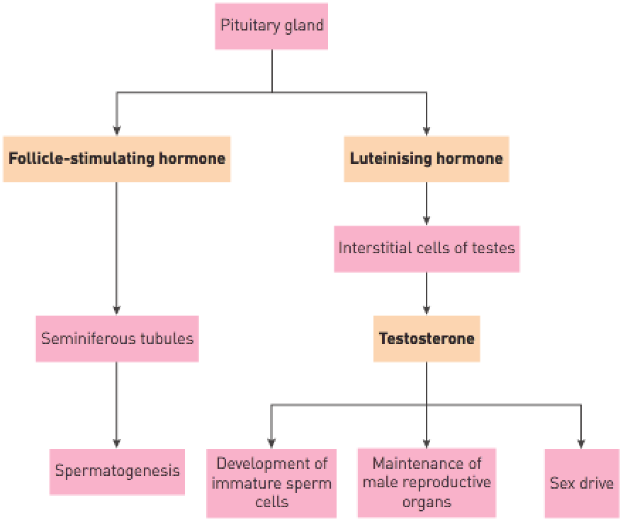

Secondary sexual characteristics:

* Secretions of sex hormones at puberty brings about the development of secondary sexual characteristics – characteristics associated with a person’s sex but **not directly involved in sexual reproduction**.
* Examples: Breasts, broadening of hips, growth of pelvic bones and deposition of fat for females and voice changes, distribution of added hair and pubic hair.